One Ocean, Many Connections
Aloha Tower Marketplace, 1 Aloha Tower Drive, Honolulu, Hawai‘i

Note: Field trips & NMEA Board meet & greet are ticketed events.
July 7, 2021 (W)
3 - 5 p.m. Registration desk open at Aloha Tower HPU Campus
5:30 p.m. HO‘OKIPA (Reception) with refreshments & cultural welcoming at Polynesian Voyaging Society (University of Hawaii Honolulu Community College Marine Education & Training Center, Sand Island)
Blowing of the Pū (conch)
Oli / Pule (chant/prayer)
Ka Kahea (introduction and invitation)
Ho‘okupu (gifting)
Hula: Halau Ka Pa Hula O Ka Lei Hulu Hiwa
July 8, 2021 (TH)
7:30 a.m. Continental Breakfast (in court outside multi-purpose room 3)
8:30 a.m. KA ‘IKE (sharing of knowledge) (Multipurpose Room 3)
Ka Ho‘omakaukau Ana (Preparation for Sharing) Kitty M. Simonds
ʻAʻohe ʻulu e loaʻa i ka pōkole o ka lou.
(No breadfruit can be reached when the picking stick is too short.)
There is no success without preparation.
8:45 a.m. Connection 1: Traditional & Modern Ways
Keynote Speaker
Presenters 1 to 3
10:15 a.m. Break (coffee, water, snacks provided)
10:30 a.m. Presenters 4 and 5
Presenter 6/Poster Session
11:30 a.m. Lunch at Pier 9 by Sam Choy

12:30 p.m. Connection 2: Land & Sea
Keynote Speaker
Presenters 1 to 5
Presenter 6/Poster Session
3:00 p.m. Break (coffee, water, snacks provided)
3:15 p.m. Connection 3: Communities & Science
Keynote speaker
Presenters 1 to 3
4:45 p.m. Ka Malama Ana (agreement on how the knowledge will be used and protected)
5:00 p.m. Holoholo (leisure time; dinner on your own: see map below for nearby restaurants)

July 9, 2021 (F)
Breakfast on your own
5:30 a.m. Field Trip: Honolulu Fish Auction at Pier 38
9:00 a.m. Field Trip: Anuenue Fisheries Research Center /Hawaiian Sealife Inc.
Or
Field Trip: Waikalua Fishpond
12:00 p.m. Lunch at Pier 9 by Sam Choy
1:30 p.m. Connection 3: Communities & Science (continued)
Presenters 4 to 5
Presenter 6/poster session
2:30 p.m. Connection 4: Local Action & Global Engagement
Keynote speaker
Presenters 1 and 2
3:40 p.m. Break (coffee, water, snacks provided)
4:00 p.m. Presenters 3 to 5
Presenter 6/Poster session
5:00 p.m. Holoholo (leisure time; dinner on your own: see map below for nearby restaurants

July 10, 2021 (Sa)
Breakfast on your own
7:00 a.m. Buses depart for field trip to Freeman Seabird Preserve and Waikiki Aquarium
8:30 a.m. Buses depart for field trip to Hanauma Bay
12:30 p.m. Buses return from field trips
12:30 p.m. Lunch at Pier 9 by Sam Choy
1:30 p.m. Connection 5: International Networks
Keynote speaker
Presenters 1 to 5
Presenter 6/Poster session
4:00 p.m. Break (coffee, water, snacks provided)
4:15 pm Closing Discussion
5:00 p.m. Meet and Greet with NMEA Board (HPU Aloha Tower Diamond Head Lanai)
6:30 p.m. Closing Dinner (HPU Aloha Tower Ballroom)

OPTIONAL POST-CONFRENCE EVENTS (additional fees)
July 12, 2021 (M) –Workshop at Hawaii Institute of Marine Biology at Coconut Island
July 13-16, 2021 (T-Th) NMEA Conference at Ala Moana Hotel
July 16-23, 2021 (F-F) Communicating Science Workshop on Maui (college credits)
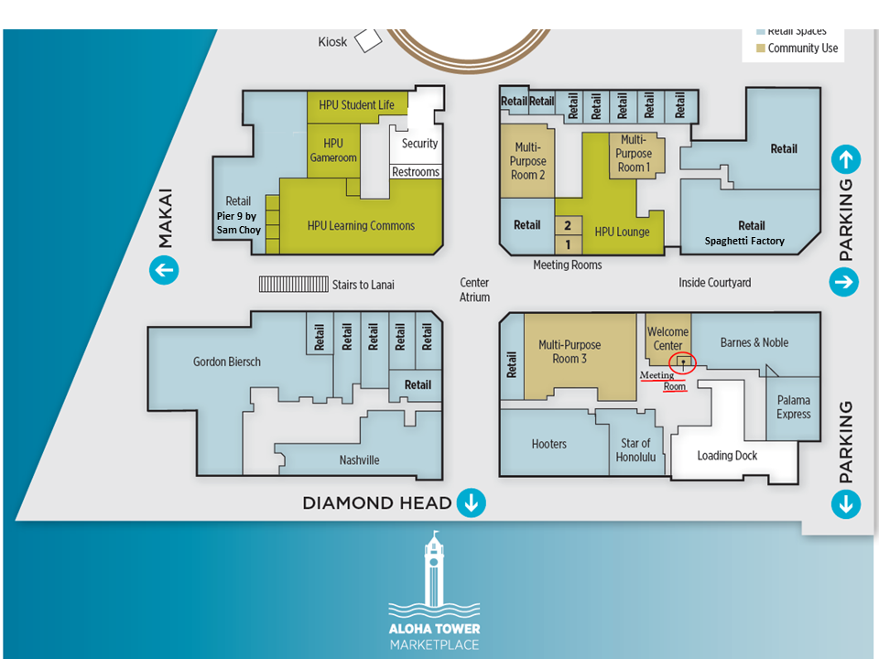

RESTAURANTS AT ALOHA TOWER MARKETPLACE

- The Old Spaghetti Factory
- Nashville
- Pier 9 by Sam Choy

PARKING BY ALOHA TOWER MARKETPLACE
There is ample parking surrounding Aloha Tower. Guests can self-park in Irwin Park or Piers 5/6. Valet parking is also available starting at 11:30AM daily off Aloha Tower Drive. The parking operation at Aloha Tower is managed by Elite Parking.
Rates are as follows:
- Self-parking with tenant validation – 1st hour free, $2 for every hour after that up to the 6th hour
- Valet parking with tenant validation - $4 flat rate for 3 hours, $20 flat rate for more than 3 hours
- Special event parking - $10 flat rate
